“Heaven’s Light is Our Guide”

Rajshahi University of Engineering & Technology



Department of Electrical and Computer Engineering

**Course No:** ECE-3118

**Course Title:**  Software Engineering & Information System Design Sessional

|  |  |
| --- | --- |
| **Submitted by:** | **Submitted to:** |
| **Name:** Nusrat Jahan Nishat  **Roll:** 1810041  **Session:** 2018-19 | Rakibul Hassan  Lecturer  Dept. of ECE |
|  | Rajshahi University of |
|  | Engineering & Technology |

**Experiment Date:**22.05.2022

**Experiment Name:** Coding for line indentation using Object Oriented Programming and 15 best practices of software engineering.

**Sample Code:**

1. #include<bits/stdc++.h>
2. using namespace std;
4. **class** align
5. {
6. **private**:
7. **int** _lengthPerLine;
8. **public**:
9. ***/** Set the length per line **/***
10. align(**int** len)
11. {
12. _lengthPerLine=len;
13. }
14. ***/** Return length per line **/***
15. **int** getLen()
16. {
17. **return** _lengthPerLine;
18. }
19. string s;
20. ***/** Take input from user **/***
21. **void** inp()
22. {
23. getline(cin,s);
24. }
25. ***/**Stores the resultant string for each line **/***
26. vector<string>res;
27. ***/** Stores the starting position of each line **/***
28. vector<int>pos;
29. ***/** process the input for required indentetion **/***
30. **void** process()
31. {
32. **int** flag=0;
33. ***/** Strores the string for required length **/***
34. string tmp;
35. ***/**stores each word **/***
36. string word;
37. ***/**Stores the starting position of each line **/***
38. **int** start=-1;
39. **for**(**int** i=0; i<s.size(); i++)
40. {
41. **if**(s[i]==' ' and !flag)
42. {
43. **continue**;
44. }
45. ++flag;
47. **if**(start == -1) start=i+1;
48. **if**(s[i] == ' ')
49. {
50. **if**(tmp.size()) tmp+=' ';
51. **if**(tmp.size()+word.size()>getLen())
52. {
53. res.push_back(tmp);
54. pos.push_back(start);
55. tmp.clear();
56. tmp+=word;
57. start=i+1-word.size();
58. word.clear();
59. }
60. **else** **if**(tmp.size()+word.size()==getLen())
61. {
62. tmp+=word;
63. res.push_back(tmp);
64. pos.push_back(start);
65. word.clear();
66. tmp.clear();
67. start=i+2;
68. }
69. **else**
70. {
71. tmp+=word;
72. word.clear();
73. }
74. **continue**;
75. }
76. word+=s[i];
77. **if**(i==s.size()-1)
78. {
79. pos.push_back(start);
80. **if**(tmp.size()) tmp+=' ';
81. **if**(tmp.size()+word.size()>getLen())
82. {
83. res.push_back(tmp);
84. start+=tmp.size();
85. pos.push_back(start);
86. res.push_back(word);
87. }
88. **else**
89. {
90. tmp+=word;
91. res.push_back(tmp);
92. }
93. }
94. }
96. }
97. ***/** Print the result **/***
98. **void** print()
99. {
100. **for**(**int** i=0; i<res.size(); i++)
101. {
103. string ss=res[i];
104. **while**(ss.back()==' ') ss.pop_back();
105. cout<<pos[i]<<" "<<pos[i]+ss.size()-1<<endl;
106. reverse(ss.begin(),ss.end());
107. **while**(ss.size()!=getLen()) ss+=' ';
108. reverse(ss.begin(),ss.end());
109. cout<<ss<<endl;
110. }
111. }
113. };
115. **int** main()
116. {
117. align work(10);
118. cout<<"Length per line is :"<<work.getLen()<<endl;
119. cout<<"Taking input : ";
120. work.inp();
121. work.process();
122. work.print();
123. }

**Output:**

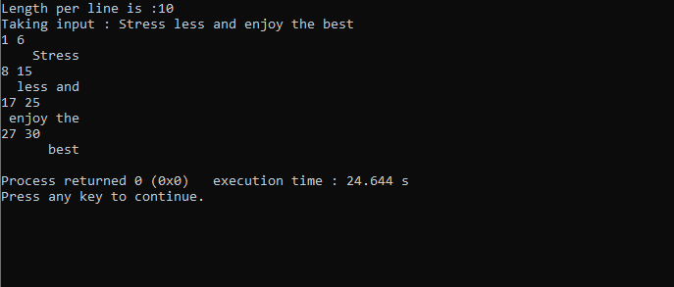

**15 best practices of software engineering :**

1. Select talent and appropriate resources

2. Choosing the Appropriate Design and Development Process.

3. Make Reasonable Budgets and Estimates

4**.** Set smaller milestones

5. Define the requirements well

6. Define System Architecture

7. Optimize your application design

8. Implement the code effectively

9. Rigorous testing and validation

10. Documentation

11. Schedule code review sessions

12. Ensure management of control of software sources

13. Quality Control

14. Effective Installation and Deployment

15. Support and Maintenance Strategy